Q1: KMeans:

from sklearn.cluster import KMeans

import pandas as pd

from sklearn.preprocessing import MinMaxScaler

from matplotlib import pyplot as plt

%matplotlib inline

df = pd.read_csv("AI.csv")

print(df.head())

plt.scatter(df.Age,df['AnnualIncome'])

plt.xlabel('Age')

plt.ylabel('AnnualIncome')

plt.show()

km = KMeans(n_clusters = 1)

y_predicted = km.fit_predict(df[['Age','AnnualIncome']])

print(y_predicted)

df['cluster'] = y_predicted

print(df.head())

km = KMeans(n_clusters=3)

y_predicted = km.fit_predict(df[['Age','AnnualIncome']])

print(y_predicted)

df['cluster'] = y_predicted

print(df.head())

print(km.cluster_centers_)

df1 = df[df.cluster==0]

df2 = df[df.cluster==1]

df3 = df[df.cluster==2]

plt.scatter(df1.Age,df1['AnnualIncome'],color='green')

plt.scatter(df2.Age,df2['AnnualIncome'],color='red')

plt.scatter(df3.Age,df3['AnnualIncome'],color='black')

plt.scatter(km.cluster_centers_[:,0],km.cluster_centers_[:,1],color='purple',marker='*',label='centroid')

plt.xlabel('Age')

plt.ylabel('AnnualIncome')

plt.legend()

plt.show()

scaler = MinMaxScaler()

df['AnnualIncome']=scaler.fit_transform(df[['AnnualIncome']])

df['Age']=scaler.fit_transform(df[['Age']])

print(df.head())

plt.scatter(df.Age,df['AnnualIncome'])

plt.xlabel('Age')

plt.ylabel('AnnualIncome')

plt.show()

km = KMeans(n_clusters=1)

y_predicted = km.fit_predict(df[['Age','AnnualIncome']])

print(y_predicted)

df['cluster'] = y_predicted

print(df.head())

print(km.cluster_centers_)

df1 = df[df.cluster == 0]

df2 = df[df.cluster == 1]

df3 = df[df.cluster == 2]

plt.scatter(df1.Age,df1['AnnualIncome'],color='green')

plt.scatter(df2.Age,df2['AnnualIncome'],color='red')

plt.scatter(df3.Age,df3['AnnualIncome'],color='black')

plt.scatter(km.cluster_centers_[:,0],km.cluster_centers_[:,1],color='purple',marker='*',label='centroid')

plt.xlabel('Age')

plt.ylabel('AnnualIncome')

plt.legend()

plt.show()

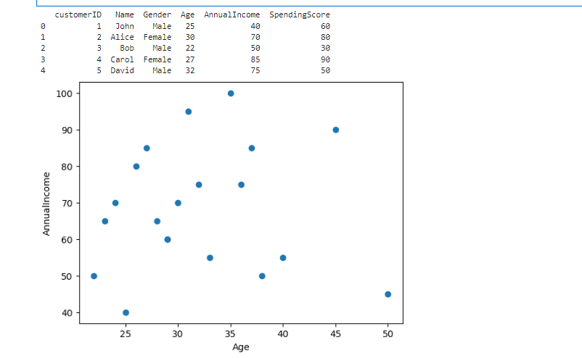

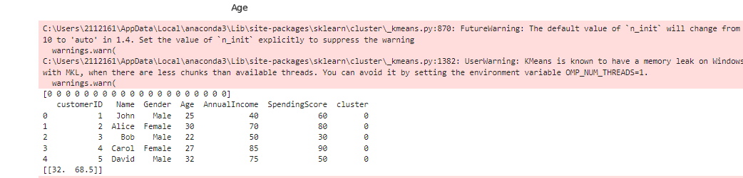

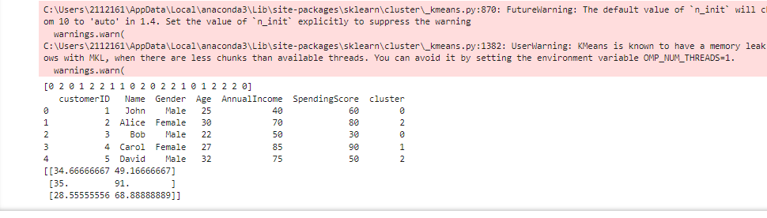

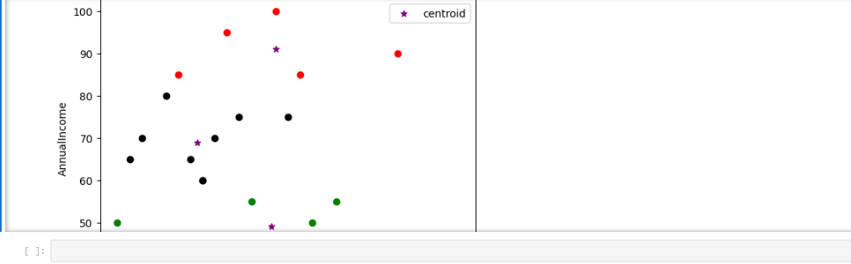

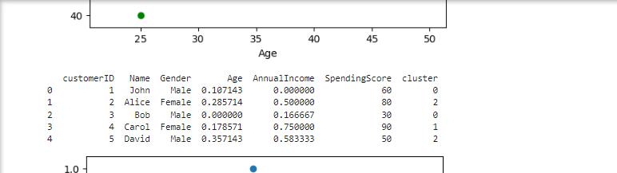

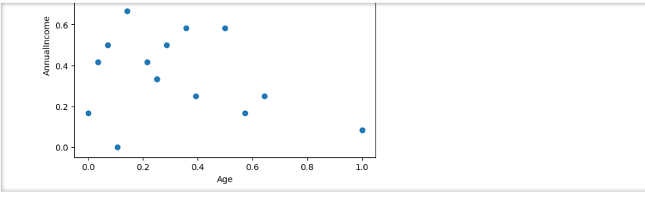

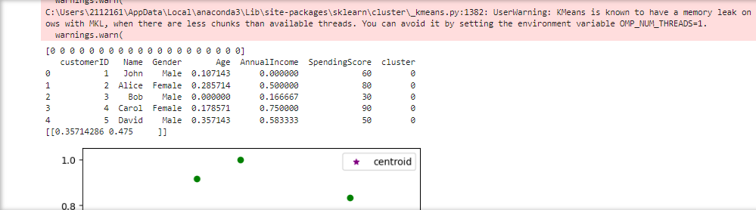

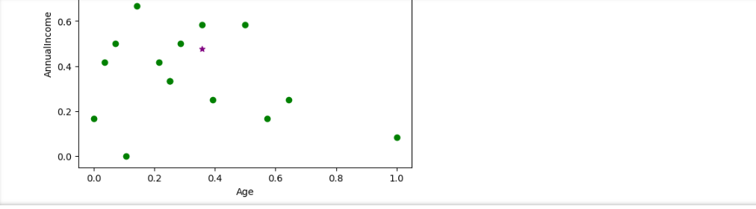

Q2: SLP

import numpy as np

class SLP(object):

def _init_(self, input_size, learning_rate = 0.1, epochs=161):

self.weights = np.zeros(input_size+1)

print("Creating weight vector, one dimensional array with zeros ", self.weights)

self.epochs = epochs

self.learning_rate = learning_rate

def activation_function(self , input_value):

return 1 if iput_value >= 0 else 0

def predict (self , input_value):

z= self.weights.T.dot(input_value)

a = self.activation_function(z)

return a

def perceptronLearning(self, given_input, desired_output):

for j in range(self.epochs):

for i in range(desired_output.shape[0]):

x=np.insert(given_input[i], 0,1)

y=self.predict(x)

e= desired_output[i]-y

print("Error: ", e)

print("Predicted output: ", y)

self.weights = self.weights + self.learning_rate * e* x

#And Gate

given_input = np.array([

[0,0],

[0,1],

[1,0],

[1,1]

])

desired_output = np.array([0,0,0,1])

print("Given Input: \n", given_input)

print("Desired output: \n", desired_output)

slp= SLP(input_size=2)

slp.perceptronLearning(given_input, desired_output)

print("Input weights with bias: \n", slp.weights)

print("Learning rate: \n", slp.learning_rate)

print("Total epochs: \n", slp.epochs)

#OR Gate

given_input = np.array([

[0,0],

[0,1],

[1,0],

[1,1]

])

desired_output = np.array([0,1,1,1])

print("Given Input: \n", given_input)

print("Desired output: \n", desired_output)

slp= SLP(input_size=2)

slp.perceptronLearning(given_input, desired_output)

print("Input weights with bias: \n", slp.weights)

print("Learning rate: \n", slp.learning_rate)

print("Total epochs: \n", slp.epochs)

#NAND Gate

given_input = np.array([

[0,0],

[0,1],

[1,0],

[1,1]

])

desired_output = np.array([1,1,1,0])

print("Given Input: \n", given_input)

print("Desired output: \n", desired_output)

slp= SLP(input_size=2)

slp.perceptronLearning(given_input, desired_output)

print("Input weights with bias: \n", slp.weights)

print("Learning rate: \n", slp.learning_rate)

print("Total epochs: \n", slp.epochs)

#NOR

given_input = np.array([

[0,0],

[0,1],

[1,0],

[1,1]

])

desired_output = np.array([1,0,0,0])

print("Given Input: \n", given_input)

print("Desired output: \n", desired_output)

slp= SLP(input_size=2)

slp.perceptronLearning(given_input, desired_output)

print("Input weights with bias: \n", slp.weights)

print("Learning rate: \n", slp.learning_rate)

print("Total epochs: \n", slp.epochs)

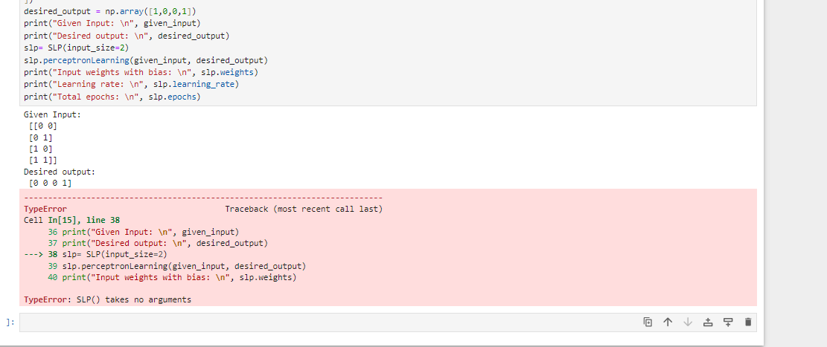

Q3: Decision Tree

import pandas as pd

from sklearn.preprocessing import LabelEncoder

from sklearn import tree

df = pd.read_csv("AI2.csv")

df.head()

inputs=df.drop(['MPG','Displacement','CylinderClass','Horsepower', 'Weight','Origin'], axis = 'columns')

target = df['MPG']

le_acceleration = LabelEncoder()

le_ModelYear = LabelEncoder()

inputs_n = df.drop(['ModelYear','Acceleration'], axis = 'columns')

inputs_n

inputs['acceleartion_n'] = le_acceleration.fit_transform(inputs['Acceleartion'])

inputs['modelyear_n'] = le_ModelYear.fit_transform(inputs['ModelYear'])

inputs

inputs_n = inputs.drop(['Acceleartion', 'ModelYear'], axis = 'columns')

inputs_n

target

model = tree.DecisionTreeClassifier()

model.fit(inputs_n, target)

model.score(inputs_n, target)

model.predict([[18, 307, 130, 3504, 12, 70]])

model.predict([[15, 350, 165, 3693, 11.5, 70]])

